T TREE GRATES

877-840-0881 www.hendrickarch.com arch@hendrickcorp.com Carbondale, PA | Owensboro, KY

Care and Maintenance Instructions

Caution During Construction: Excessive loads can cause significant damage to the product. Unsuitable loads include automobiles, forklifts and scissor (genie) lifts. When it’s absolutely necessary for this type of equipment to cross the grille, it must be completely supported underneath and the surface must be covered with stainless plate to protect the tops of the bars.

ANTI-SLIP FINISH PROTECTION

If the entrance grille includes an anti-slip finish (see image below), please be sure to avoid the following contaminants:
▪ Carbon steel
▪ Snow/ice removal chemicals, including salt
▪ Cleaning products containing ammonia or bleach
▪ Floor buffing cleaners or waxes which may become imbedded in the anti-slip product

If exposed to any of these contaminants, the grille may develop discoloration, rust or unrepairable damage. If contact happens, immediately remove the contaminate and clean the grille with a high- pressure washer. If the discoloration or contamination cannot be removed, contact your Hendrick representative for additional remedies.

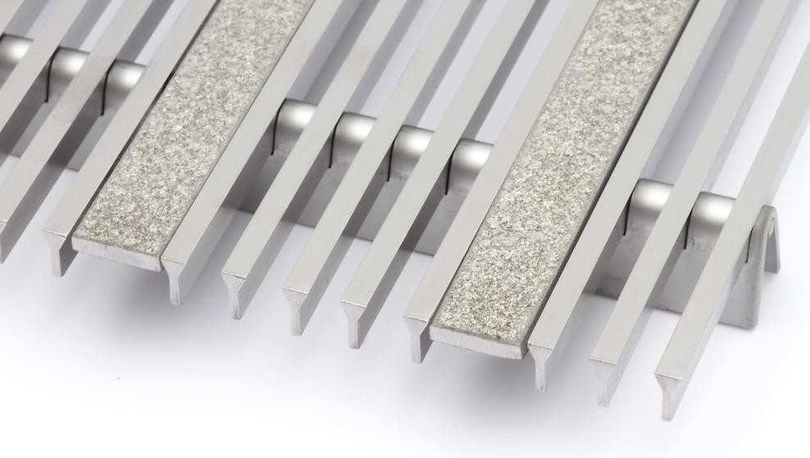Example of Anti-Slip Coating on Hendrick’s Entrance Grille

GRILLE REMOVAL

*Gloves are recommended when handling the grilles to protect against sharp edges.

When removing multiple grilles, we recommend tagging the grilles to match their locations prior to removal. This will insure they are replaced in the correct locations.

Use of a hex wrench or screw driver may be necessary to loosen any attachment screws that were used to fasten the grilles to the concrete or frame.

When grilles are removed, inspect them carefully. Wires that are slightly bent due to prior damage can be straightened with pliers or a chisel before replacing.

REINSTALLATION

Make absolutely sure that there is no debris in the area that will not allow the grille to set level. Re- place the grilles to their original locations paying particular attention to alignment between any mounting brackets and any hole locations in the floor or frame. Replace screws in areas required.

CLEANING

In order to work properly, the grilles require periodic cleaning. General cleaning can be done from the surface with a vacuum and brush to remove debris between the bars.

For a more thorough cleaning, the grilles should be removed from the recess by following the removal instructions provided. Once grilles are removed, a vacuum or power sprayer should be used. Spots can be treated using a cleaner that is suitable for use on stainless steel products.

CONTACT INFORMATION

Please contact Hendrick Screen Company at 270-685-5138 if you have any questions.

